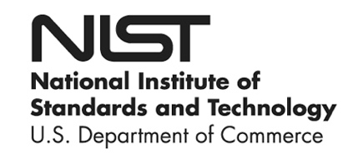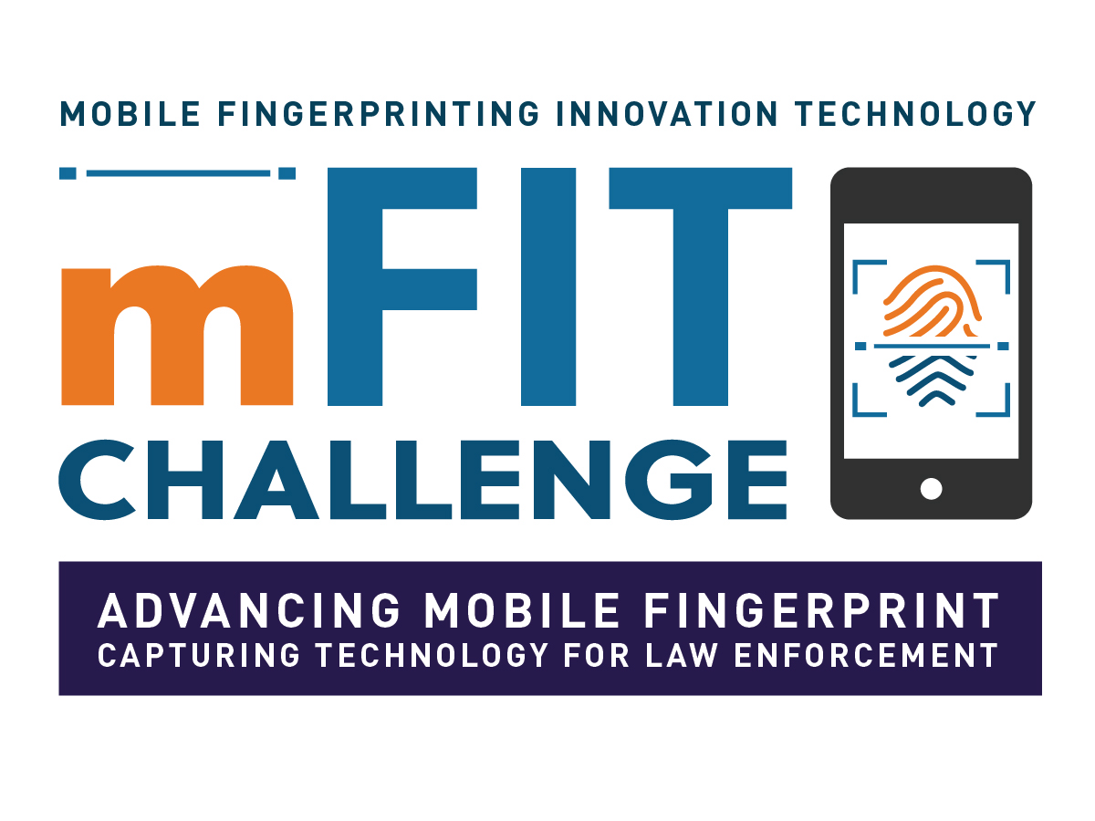

DEMONSTRATION NOTICE

NIST, PSCR invites you to interact with mobile fingerprinting prototypes submitted to the Mobile Fingerprint Innovation Technology Challenge. All prototypes are property of the Department of Commerce and are to be used for demonstration purposes only.

Your participation is entirely voluntary.

**How will my data be used?**

Interacting with the devices may result in your fingerprints being captured. Any information collected will remain solely on the prototype device. All prototype devices used in this demonstration along with all data will be irreversibly destroyed at the end of their useful demonstration life. Data collected as part of the demonstration will not be used for evaluation, study, or any other purpose.

Questions? Comments? Contact: Gary Howarth, Physical Scientist, PSCR at gary.howarth@nist.gov